**Servlet FAQ’s**

1. **How many objects of a servlet is created?**

Only one object at the time of first request by servlet or web container.

1. **What is the life-cycle of a servlet?**

Following the stages of servlet life cycle:  
**1) Loading of Servlet class**: The servlet container finds the servlet class mentioned in web.xml file and loads it.  
**2)** **Servlet instantiation**: The object of servlet class gets created in this phase.  
**3) Initialization**: Servlet initialization by calling init() method.  
4**) Servicing the request**: In this phase the servlet service the client request by calling the service()method.  
5**) Destroy:** Last phase of servlet life cycle. The destroy() method free up the servlet instance so that it can be garbage collected.

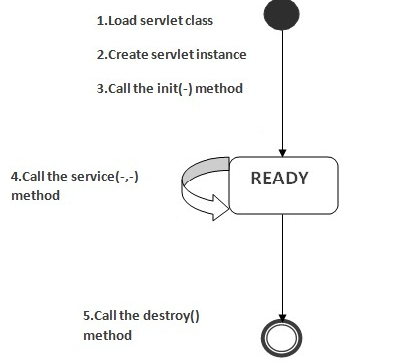

1. **What is the advantage of servlet?**

* Servlets provide a way to generate dynamic documents that is both easier to write and faster to run.
* provide all the powerfull features of JAVA, such as Exception handling and garbage collection.
* Servlet enables easy portability across Web Servers.

### What is the disadvantage of servlet?

* Designing in servlet is difficult and slows down the application.
* Writing complex business logic makes the application difficult to understand.
* You need a Java Runtime Environment on the server to run servlets.

### What are the life-cycle methods for a servlet?

#### public void init ():

Whenever client makes a request to a servlet, the server will receive the request and it automatically calls init () method i.e., init () method will be called only one time by the server whenever we make first request.

#### public void service (ServletRequest, ServletResponse):

After calling init () method, service () method will be called when we make first request from second request to further subsequent requests, server will call only service method. Therefore, service () method will be called each and every time as and when we make a request.

#### public void destroy ():

The destroy () method will be called by the server in two situations; they are when the server is closed and when the servlet is removed from server context. In this method we write the block of statements which are obtained in init () method.

### Who is responsible to create the object of servlet?

### The web container or servlet container.

### When servlet object is created?

### At the time of first request.

### What is difference between Get and Post method?

|  |  |
| --- | --- |
| **Get** | **Post** |
| 1) Limited amount of data can be sent because data is sent in header. | Large amount of data can be sent because data is sent in body. |
| 2) Not Secured because data is exposed in URL bar. | Secured because data is not exposed in URL bar. |
| 3) Can be bookmarked | Cannot be bookmarked |
| 4) Idempotent | Non-Idempotent |
| 5) It is more efficient and used than Post | It is less efficient and used |

### What is difference between PrintWriter and ServletOutputStream?

### PrintWriter is a character-stream class where as ServletOutputStream is a byte-stream class. The PrintWriter class can be used to write only character-based information whereas ServletOutputStream class can be used to write primitive values as well as character-based information.

### What is difference between GenericServlet and HttpServlet?

### The GenericServlet is protocol independent whereas HttpServlet is HTTP protocol specific. HttpServlet provides additional functionalities such as state management etc.

### What is servlet collaboration?

When one servlet communicates to another servlet, it is known as servlet collaboration. There are many ways of servlet collaboration:

* RequestDispacher interface
* sendRedirect() method etc.

### What is difference between ServletConfig and ServletContext?

The container creates object of ServletConfig for each servlet whereas object of ServletContext is created for each web application.

### What are Cookies?

### A cookie is a small piece of information that is persisted between the multiple client requests. A cookie has a name, a single value, and optional attributes such as a comment, path and domain qualifiers, a maximum age, and a version number.

### What is difference between Cookies and HttpSession?

### Cookie works at client side whereas HttpSession works at server side.

### What is the use of attribute in servlets?

### Attribute is a map object that can be used to set, get or remove in request, session or application scope. It is mainly used to share information between one servlet to another.

### What are the annotations used in Servlet 3?

There are mainly 3 annotations used for the servlet.

1. @WebServlet : for servlet class.
2. @WebListener : for listener class.
3. @WebFilter : for filter class.

### What is the disadvantage of cookies?

### It will not work if cookie is disabled from the browser.

### Which event is fired at the time of setting, getting or removing attribute from application scope?

ServletContextAttributeEvent.

1. **What is filter?**

### A filter is an object that is invoked either at the preprocessing or postprocessing of a request. It is pluggable.

### What is difference between Cookies and HttpSession?

Cookie works at client side whereas HttpSession works at server side.